Project Report  
OBJECT FEATURE EXTRACTION THROUGH REFLECTANCE USING HYPER SPECTRAL IMAGING TECHNIQUE

*Submitted in the partial fulfilment of the requirements for  
the award of the degree of*

**BACHELOR OF TECHNOLOGY**

In

**ELECTRONICS AND COMMUNICATION ENGINEERING**

By

**P. USHA SREE 16311A0475**

**S. SAHITHI 16311A0490**

**T. ANJALI SHIVANI REDDY 16311A0494**

**UNDER THE GUIDANCE OF**

**Dr .J .CHATTOPADHYAY**

**Professor, E.C.E Department**



**DEPARTMENT OF ELECTRONICS & COMMUNICATION ENGINEERING**

**SREENIDHI INSTITUTE OF SCIENCE & TECHNOLOGY**

**Yamnampet (V), Ghatkesar (M), Hyderabad – 501 301.**

**April 2019**

**SREENIDHI INSTITUTE OF SCIENCE AND TECHNOLOGY   
(Affiliated to Jawaharlal Nehru Technological University, Hyderabad)  
Yamnampet (V), Ghatkesar (M), Hyderabad – 501 301**



**CERTIFICATE**

This is to certify that the project report entitled ***“*PATERN** **IDENTIFICATION OF OBJECT OF SPECTRAL REFLECTANCE USING HYPER SPECTRAL IMAGING** **TECHNIQUE**”is being submitted by

**P. USHA SREE 16311A0475**

**S. SAHITHI 16311A0490**

**T. ANJALI SHIVANI REDDY 16311A0494**

in partial fulfilment of the requirements for the award of **Bachelor of Technology** degree in **Electronics and Communication Engineering** to **Sreenidhi Institute of Science & Technology** affiliated to **Jawaharlal Nehru Technological University, Hyderabad** (Telangana)**.** This record is a bona fide work carried out by them under our guidance and supervision. The results embodied in the report have not been submitted to any other University or Institution for the award of any degree or diploma.

**Internal Guide Project Coordinator**

**Name of internal guide Name of Coordinator**

**Designation Designation**

**Head of the Department** Dr. S.P.V. SUBBA RAO  
Professor, Department of ECE

**DECLARATION**

We hereby declare that the work described in this thesis titled **“PATERN** **IDENTIFICATION OF OBJECT OF SPECTRAL REFLECTANCE USING HYPER SPECTRAL IMAGING** **TECHNIQUE”** which is being submitted by us in partial fulfilment for the award of Bachelor of Technology in the Department of **Electronics and Communication Engineering,** Sreenidhi Institute Of Science & Technology is the result of investigations carried out by us under the guidance of **Name of internal guide, Designation, Department of ECE, Sreenidhi Institute of Science & Technology, Hyderabad.**

No part of the thesis is copied from books/ journals/ internet and whenever the portion is taken, the same has been duly referred. The report is based on the project work done entirely by us and not copied from any other source. The work is original and has not been submitted for any Degree/Diploma of this or any other university.

Place: Hyderabad

Date:

**P. USHA SREE 16311A0475**

**S. SAHITHI 16311A0490**

**T. ANJALI SHIVANI REDDY 16311A0494**

**ACKNOWLEDGEMENTS**

We thank **Dr.S.Ramani, Associate Professor**, **Dr .J .Chattopayay, professor**, Dept. of ECE, Sreenidhi Institute of Science & Technology, Hyderabad for her valuable comments and suggestions that greatly helped in improving quality of thesis.

We would like to express our sincere gratitude to **Dr. S.P.V. Subbarao**, Professor, Head of the department, Electronics & Communication Engineering, Sreenidhi Institute of Science & Technology, Hyderabad for his continued support and valuable guidance and encouragement extended to us during our research work. We thank him for his painstaking efforts to guide us throughout our research work.

We are very grateful to **Dr. P. NARSIMHA REDDY, Director** and **Dr. Siva Reddy**, **Principal** and the Management of **Sreenidhi Institute Of Science & Technology** for having provided the opportunity for taking up this project.

We thank to all my teachers and professors for their valuable comments after reviewing our research papers.

We wish to extend my special thanks to all my colleagues and friends who helped directly or indirectly to complete our research work.

We extend our thanks to our parents and all our family members for their unceasing encouragement and support who wished us a lot to complete this work.

**TABLE OF CONTENTS**

| Chapter No. | Title | Page  No. |
| --- | --- | --- |
|  | INDEX ---------------------------------------------------------------------------------------- | IV |
|  | LIST OF FIGURES ---------------------------------------------------------------------------------------- | VI |
|  | LIST OF TABLES ---------------------------------------------------------------------------------------- | VIII |
|  | ABBREVIATIONS ---------------------------------------------------------------------------------------- | X |
|  | ABSTRACT ----------------------------------------------------------------------------------------……… | XII |
| **CHAPTER 1: INTRODUCTION** ---------------------------------------------------------------------------------------- | | 1 |
| 1.0 | Introduction ---------------------------------------------------------------------------------------- |  |
| 1.1 | Brief History ------------------------------------------------------------------------------- |  |
| 1.2 | Problem Statement ------------------------------------------------------------------------------- |  |
| 1.3 | Motivation ------------------------------------------------------------------------------- |  |
| 1.4 | Objectives of the Project ------------------------------------------------------------------------------- |  |
| 1.5 | Existing Method ------------------------------------------------------------------------------- |  |
| 1.6 | Proposed Method ------------------------------------------------------------------------------- |  |
| 1.7 | Organization of the Project Report -------------------------------------------------------  -------------------------- |  |
| **CHAPTER 2:SPECTRAL REFLECTANCE** ---------------------------------------------------------------------------------------- | |  |
| 2.0 | Introduction ---------------------------------------------------------------------------------------- |  |
| 2.1 | Literature Review ---------------------------------------------------------------------------------------- |  |
| **CHAPTER 3: SPECTRAL IMAGING** | |  |
| 3.0 | Introduction ---------------------------------------------------------------------------------------- |  |
| 3.1 | Spectral libraries------------------------------------------------------------------------------  plo-------------------------------------------------------------------------------------------- |  |
|  |  |  |
|  |  |  |
| **CHAPTER 4:SPECTRAL LIBRARIES** | |  |
| 4.0 | Introduction ---------------------------------------------------------------------------------------- |  |
| 4.1 | Plotting spectra in spectral space-------------------------------------------------------------------------------------------- |  |
| 4.2 | Spatial resolution and mixed spectra -------------------------------------------------------------------------------------------- |  |
|  |  |  |
| **CHAPTER 5:RADIANCE AND REFLECTANCE** | |  |
| 5.0 | Introduction ---------------------------------------------------------------------------------------- |  |
| 5.1 | Reflectance conversion  s -------------------------------------------------------------------------------------------- |  |
| 5.2 | Strategies for image analysis ------------------------------------------------------------- |  |
|  | ------------- |  |
| **CHAPTER 6:SPECTRAL MATCHING**  **CH** | |  |
| 6.0 | Introduction ---------------------------------------------------------------------------------------- |  |
| 6.1 | Match each image spectrum ---------------------------------------------------------------  ----------------------------- |  |

**CHAPTER 7:ADVANTAGES**

**CHAPTER 8:DISADVANTAGES**

**CHAPTER 9:CONCLUSION AND FUTURE SCOPE**

9.0 conclusions----------------------------------------------------------------------------------------------

9.1 Future scope---------------------------------------------------------------------------------------------

**REFERENCE**

**Appendix:A.1----------------------------------------------------------------------------------------------**

**Appendix: A.2----------------------------------------------------------------------------------------------**

**ABSTRACT**

**Hyperspectral imaging**, like other [spectral imaging](https://en.wikipedia.org/wiki/Spectral_imaging), collects and processes information from across the [electromagnetic spectrum](https://en.wikipedia.org/wiki/Electromagnetic_spectrum). The goal of hyperspectral imaging is to obtain the spectrum for each pixel in the image of a scene, with the purpose of finding objects, identifying materials, or detecting processes. There are three general branches of spectral imagers. There are [push broom scanners](https://en.wikipedia.org/wiki/Push_broom_scanner) and the related [whisk broom scanners](https://en.wikipedia.org/wiki/Whisk_broom_scanner) (spatial scanning), which read images over time, band sequential scanners (spectral scanning), which acquire images of an area at different wavelengths, and [snapshot hyperspectral imaging](https://en.wikipedia.org/wiki/Snapshot_hyperspectral_imaging), which uses a [staring array](https://en.wikipedia.org/wiki/Staring_array) to generate an image in an instant.

Reflectance difference spectroscopy is a spectroscopic technique which measures the difference in reflectance of two beams of light that are shone in normal incident on a surface with different linear polarizations. It is also known as reflectance anisotropy spectroscopy.

Here in this project we made an attempt to process the image from the Hyperspectral sensor of already obtained data from prior art, we tried to analyse the pattern of image formed using digital camera and spectroscopy based on how much energy is reflectance, incident and other parameters which are combined to form a three-dimensional (*x*,*y*,*λ*) hyperspectral [data cube](https://en.wikipedia.org/wiki/Data_cube) for processing and analysis, where *x* and *y* represent two spatial dimensions of the scene, and *λ* represents the spectral dimension (comprising a range of wavelengths). By using Mathwork to reduce noise and for easy and proper implementation of the project with well defined and tested algorithms.

This has many applications beside food processing , Mineralogy like it is used for astronomical telescope , Tracking object and Explosive detection . Further we Want to developer this project to identify the particulars size and concentration .

**1.1 INTRODUCTION**

For much of the past decade, hyperspectral imaging has been an area of active research and development, and hyperspectral images have been available only to researchers. With the recent appearance of commercial airborne hyperspectral imaging systems, hyperspectral imaging is poised to enter the mainstream of remote sensing. Hyperspectral images will find many applications in resource management, agriculture, mineral exploration, and environmental monitoring. But effective use of hyperspectral images requires an understanding of the nature and limitations of the data and of various strategies for processing and interpreting it. This booklet aims to provide an introduction to the fundamental concepts in the field of hyperspectral imaging. Sample Data Some illustrations in this booklet show analysis results for a hyperspectral scene of Cuprite, Nevada. This scene was acquired using the Airborne Visible/Infrared Imaging Spectrometer (AVIRIS), which is operated by the NASA Jet Propulsion Laboratory. The same scene is used in the exercises in the companion tutorial booklet Analyzing Hyperspectral Images. You can download this scene in the TNTmips Project File format (along with associated sample data) from the MicroImages web site. More Documentation This booklet is intended only as a general introduction to hyperspectral imaging. In TNTmips, hyperspectral images can be processed and analyzed using the Hyperspectral Analysis process (choose Image / Hyperspectral Analysis from the TNTmips menu). For an introduction to this process, consult the tutorial booklet entitled Analyzing Hyperspectral Images. Additional background information can be found in the booklet Introduction to Remote Sensing of Environment (RSE). TNTmips® Pro and TNTmips Free TNTmips (the Map and Image Processing System) comes in three versions: the professional version of TNTmips (TNTmips Pro), the low-cost TNTmips Basic version, and the TNTmips Free version. All versions run exactly the same code from the TNT products DVD and have nearly the same features. If you did not purchase the professional version (which requires a software license key) or TNTmips Basic, then TNTmips operates in TNTmips Free mode. R

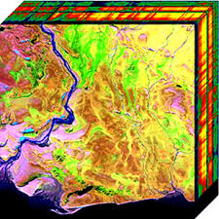

Multispectral remote sensors such as the Landsat Thematic Mapper and SPOT XS produce images with a few relatively broad wavelength bands. Hyperspectral remote sensors, on the other hand, collect image data simultaneously in dozens or hundreds of narrow, adjacent spectral bands. These measurements make it possible to derive a continuous spectrum for each image cell, as shown in the illustration below. After adjustments for sensor, atmospheric, and terrain effects are applied, these image spectra can be compared with field or laboratory reflectance spectra in order to recognize and map surface materials such as particular types of vegetation or diagnostic minerals associated with ore deposits. Hyperspectral images contain a wealth of data, but interpreting them requires an understanding of exactly what properties of ground materials we are trying to measure, and how they relate to the measurements actually made by the hyperspectral sensor. Images acquired simultaneously in many narrow, adjacent wavelength bands.

**1.1 IMAGING SPECTROMETER**

The development of these complex sensors has involved the convergence of two related but distinct technologies: spectroscopy and the remote imaging of Earth and planetary surfaces. Spectroscopy is the study of light that is emitted by or reflected from materials and its variation in energy with wavelength. As applied to the field of optical remote sensing, spectroscopy deals with the spectrum of sunlight that is diffusely reflected (scattered) by materials at the Earthís surface. Instruments called spectrometers (or spectroradiometers) are used to make ground-based or laboratory measurements of the light reflected from a test material. An optical dispersing element such as a grating or prism in the spectrometer splits this light into many narrow, adjacent wavelength bands and the energy in each band is measured by a separate detector. By using hundreds or even thousands of detectors, spectrometers can make spectral measurements of bands as narrow as 0.01 micrometers over a wide wavelength range, typically at least 0.4 to 2.4 micrometers (visible through middle infrared wavelength ranges). Remote imagers are designed to focus and measure the light reflected from many adjacent areas on the Earthís surface. In many digital imagers, sequential measurements of small areas are made in a consistent geometric pattern as the sensor platform moves and subsequent processing is required to assemble them into an image. Until recently, imagers were restricted to one or a few relatively broad wavelength bands by limitations of detector designs and the requirements of data storage, transmission, and processing. Recent advances in these areas have allowed the design of imagers that have spectral ranges and resolutions comparable to ground-based spectrometers.

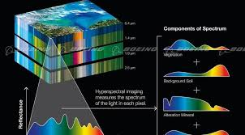

**2. SPECTRAL REFLECTANCE**

In reflected-light spectroscopy the fundamental property that we want to obtain is spectral reflectance: the ratio of reflected energy to incident energy as a function of wavelength. Reflectance varies with wavelength for most materials because energy at certain wavelengths is scattered or absorbed to different degrees. These reflectance variations are evident when we compare spectral reflectance curves (plots of reflectance versus wavelength) for different materials, as in the illustration below. Pronounced downward deflections of the spectral curves mark the wavelength ranges for which the material selectively absorbs the incident energy. These features are commonly called absorption bands (not to be confused with the separate image bands in a multispectral or hyperspectral image). The overall shape of a spectral curve and the position and strength of absorption bands in many cases can be used to identify and discriminate different materials. For example, vegetation has higher reflectance in the near infrared range and lower reflectance of red light than soils.

The spectral reflectance curves of healthy green plants also have a characteristic shape that is dictated by various plant attributes. In the visible portion of the spectrum, the curve shape is governed by absorption effects from chlorophyll and other leaf pigments. Chlorophyll absorbs visible light very effectively but absorbs blue and red wavelengths more strongly than green, producing a characteristic small reflectance peak within the green wavelength range. As a consequence, healthy plants appear to us as green in color. Reflectance rises sharply across the boundary between red and near infrared wavelengths (sometimes referred to as the red edge) to values of around 40 to 50% for most plants. This high near-infrared reflectance is primarily due to interactions with the internal cellular structure of leaves. Most of the remaining energy is transmitted, and can interact with other leaves lower in the canopy. Leaf structure varies significantly between plant species, and can also change as a result of plant stress. Thus species type, plant stress, and canopy state all can affect near infrared reflectance measurements. Beyond 1.3 µm reflectance decreases with increasing wavelength, except for two pronounced water absorption bands near 1.4 and 1.9 µm.

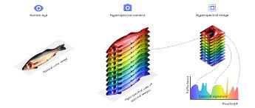

**3. WHY HYPER SPECTRAL IMAGING**

Hyperspectral imaging (HSI) is a technique that analyzes a wide spectrum of light instead of just assigning primary colors (red, green, blue) to each pixel. The light striking each pixel is broken down into many different spectral bands in order to provide more information on what is imaged.

Spectral mixtures can be macroscopic or intimate. In a macroscopic mixture each reflected photon interacts with only one surface material. The energy reflected from the materials combines additively, so that each materialís contribution to the composite spectrum is directly proportional to its area within the pixel. An example of such a linear mixture is shown in the illustration above, which could represent a patchwork of vegetation and bare soil. In spectral space each endmember spectrum defines the end of a mixing line (for two endmembers) or the corner of a mixing space (for greater numbers of endmembers). Later we will discuss how the endmember fractions can be calculated for each pixel. In an intimate mixture, such as the microscopic mixture of mineral particles found in soils, a single photon interacts with more than one material. Such mixtures are nonlinear in character and therefore more difficult to unravel.

**4.1 Spectral Libraries**

Several libraries of reflectance spectra of natural and man-made materials are available for public use. These libraries provide a source of reference spectra that can aid the interpretation of hyperspectral and multispectral images. ASTER Spectral Library This library has been made available by NASA as part of the Advanced Spaceborne Thermal Emission and Reflection Radiometer (ASTER) imaging instrument program. It includes spectral compilations from NASAís Jet Propulsion Laboratory, Johns Hopkins University, and the United States Geological Survey (Reston). The ASTER spectral library currently contains nearly 2000 spectra, including minerals, rocks, soils, man-made materials, water, and snow. Many of the spectra cover the entire wavelength region from 0.4 to 14 µm. The library is accessible interactively via the Worldwide Web at http:// speclib.jpl.nasa.gov. You can search for spectra by category, view a spectral plot for any of the retrieved spectra, and download the data for individual spectra as a text file. These spectra can be imported into a TNTmips spectral library. You can also order the ASTER spectral library on CD-ROM at no charge from the above web address.

USGS Spectral Library The United States Geological Survey Spectroscopy Lab in Denver, Colorado has compiled a library of about 500 reflectance spectra of minerals and a few plants over the wavelength range from 0.2 to 3.0 µm. This library is accessible online at http://speclab.cr.usgs.gov/spectral.lib04/spectral-lib04.html. You can browse individual spectra online, or download the entire library. The USGS Spectral library is also included as a standard reference library in the TNTmips Hyperspectral Analysis process.

4.2 Plotting Spectra in Spectral Space

The spectral plots on the previous pages provide a convenient way to visualize the differences in spectral properties between different materials, especially when we are comparing only a few spectra. Spectral plots are an important tool to use when you explore a hyperspectral image. But to understand how a computer compares and discriminates among a large number of spectra, it is useful to consider other conceptual ways of representing spectra. A reflectance spectrum consists of a set of reflectance values, one for each spectral channel (band). Each of these channels can be considered as one dimension in a hypothetical n-dimensional spectral space, where n is the number of spectral channels. If we plot the measured reflectance value for each spectral channel on its respective coordinate axis, we can use these coordinates to specify the location of a point in spectral space that mathematically represents that particular spectrum. A simple two-band example is shown in the illustration. The designated point can also be treated mathematically as the end point of a vector that begins at the origin of the coordinate system. Spectra with the same shape but differing overall reflectance (albedo) plot as vectors with the same orientation but with endpoints at different distances from the origin. Shorter spectral vectors represent darker spectra and longer vectors represent brighter spectra. It may be difficult to visualize such a plot for an image involving more than three wavelength bands, but it is mathematically possible to construct a hyperdimensional spectral space defined by dozens or hundreds of mutually-perpendicular coordinate axes. Each spectrum being considered occupies a position in this n-dimensional spectral space. Similarity between spectra can be judged by the relative closeness of these positions (spectral distance) or by how small the angle is between the spectral vectors. The spectral reflectance curves shown on the previous pages for various materials represent ìaveragesî or ìtypical examplesî. All natural materials exhibit some variability in composition and structure that results in variability in their reflectance spectra. If we obtain spectra from a number of examples of a material, the resulting spectral points will define a small cloud in n-dimensional spectral space, rather than plotting at one single location.

**4.3 Spatial Resolution and Mixed Spectra**

An imaging spectrometer makes spectral measurements of many small patches of the Earthís surface, each of which is represented as a pixel (raster cell) in the hyperspectral image. The size of the ground area represented by a single set of spectral measurements defines the spatial resolution of the image and depends on the sensor design and the height of the sensor above the surface. NASAís Airborne Visible/Infrared Imaging Spectrometer (AVIRIS), for example, has a spatial resolution of 20 meters when flown at its typical altitude of 20 kilometers, but a 4-meter resolution when flown at an altitude of 4 kilometers. When the size of the ground resolution cell is large, it is more likely that more than one material contributes to an individual spectrum measured by the sensor. The result is a composite or mixed spectrum, and the ìpureî spectra that contribute to the mixture are called endmember spectra. Spectral mixtures can be macroscopic or intimate. In a macroscopic mixture each reflected photon interacts with only one surface material. The energy reflected from the materials combines additively, so that each materialís contribution to the composite spectrum is directly proportional to its area within the pixel. An example of such a linear mixture is shown in the illustration above, which could represent a patchwork of vegetation and bare soil. In spectral space each endmember spectrum defines the end of a mixing line (for two endmembers) or the corner of a mixing space (for greater numbers of endmembers). Later we will discuss how the endmember fractions can be calculated for each pixel. In an intimate mixture, such as the microscopic mixture of mineral particles found in soils, a single photon interacts with more than one material. Such mixtures are nonlinear in character and therefore more difficult to unravel.

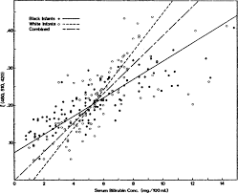

**4.4 Radiance and Reflectance**

From the discussions on the preceding pages, it should be clear that spectral reflectance is a property of ground features that we would like to be able to measure precisely and accurately using an airborne or satellite hyperspectral sensor. But look at the brightness spectrum in the illustration below. This is the average of 25 image spectra measured by the AVIRIS sensor over a bright dry lake bed surface in the Cuprite, Nevada scene. The input spectra have been adjusted for sensor effects using on-board calibration data, but no other transformations have been applied. This spectrum does not bear much resemblance to the reflectance spectra illustrated previously. This is because the sensor has simply measured the amount of reflected light reaching it in each wavelength band (spectral radiance), in this case from an altitude of 20 kilometers. The spectral reflectance of the surface materials is only one of the factors affecting these measured values. The spectral reflectance curve for the sample area is actually relatively flat and featureless. In addition to surface reflectance, the spectral radiance measured by a remote sensor depends on the spectrum of the input solar energy, interactions of this energy during its downward and upward passages through the atmosphere, the geometry of illumination for individual areas on the ground, and characteristics of the sensor system. These additional factors not only affect our ability to retrieve accurate spectral reflectance values for ground features, but also introduce additional within-scene variability which hampers comparisons between individual image cells. These factors are discussed in more detail on the next two pages

**5.1 Reflectance Conversion**

In order to directly compare hyperspectral image spectra with reference reflectance spectra, the encoded radiance values in the image must be converted to reflectance. A comprehensive conversion must account for the solar source spectrum, lighting effects due to sun angle and topography, atmospheric transmission, and sensor gain. In mathematical terms, the ground reflectance spectrum is multiplied (on a wavelength per wavelength basis) by these effects to produce the measured radiance spectrum. Two other effects contribute in an additive fashion to the radiance spectrum: sensor offset (internal instrument noise) and path radiance due to atmospheric scattering. Several commonly used reflectance conversion strategies are discussed below and on the following page. Some strategies use only information drawn from the image, while others require varying degrees of knowledge of the surface reflectance properties and the atmospheric conditions at the time the image was acquired. Flat Field Conversion This image-based method requires that the image include a uniform area that has a relatively flat spectral reflectance curve. The mean spectrum of such an area would be dominated by the combined effects of solar irradiance and atmospheric scattering and absorption The scene is converted to ìrelativeî reflectance by dividing each image spectrum by the flat field mean spectrum. The selected flat field should be bright in order to reduce the effects of image noise on the conversion. Since few if any materials in natural landscapes have a completely flat reflectance spectrum, finding a suitable ìflat fieldî is difficult for most scenes. For desert scenes, salt-encrusted dry lake beds present a relatively flat spectrum, and bright man-made materials such as concrete may serve in urban scenes. Any significant spectral absorption features in the flat field spectrum will give rise to spurious features in the calculated relative reflectance spectra. If there is significant elevation variation within the scene, the converted spectra will also incorporate residual effects of topographic shading and atmospheric path differences

**5.2 Strategies for Image Analysis**

The table below lists some of the imaging spectrometers currently being operated for research or commercial purposes. The hyperspectral images produced by these sensors present a challenge for the analyst. They provide the fine spectral resolution needed to characterize the spectral properties of surface materials but the volume of data in a single scene can seem overwhelming. The difference in spectral information between two adjacent wavelength bands is typically very small and their grayscale images therefore appear nearly identical. Much of the data in a scene therefore would seem to be redundant, but embedded in it is critical information that often can be used to identify the ground surface materials. Finding appropriate tools and approaches for visualizing and analyzing the essential information in a hyperspectral scene remains an area of active research. Most approaches to analyzing hyperspectral images concentrate on the spectral information in individual image cells, rather than spatial variations within individual bands or groups of bands. The statistical classification (clustering) methods often used with multispectral images can also be applied to hyperspectral images but may need to be adapted to handle their high dimensionality (Landgrebe, in press). More sophisticated methods combine both spectral and spatial analysis. The following pages detail some of the popular methods of analyzing the spectral content of hyperspectral images.

**5.3 Match Each Image Spectrum**

One approach to analyzing a hyperspectral image is to attempt to match each image spectrum individually to one of the reference reflectance spectra in a spectral library. This approach requires an accurate conversion of image spectra to reflectance. It works best if the scene includes extensive areas of essentially pure materials that have corresponding reflectance spectra in the reference library. An observed spectrum will typically show varying degrees of match to a number of similar reference spectra. The matching reference spectra must be ranked using some measure of goodness of fit, with the best match designated the iwinner.î Spectral matching is complicated by the fact that most hyperspectral scenes include many image pixels that represent spatial mixtures of different materials (see page 10). The resulting composite image spectra may match a variety of ìpureî reference spectra to varying degrees, perhaps including some spectra of materials that are not actually present. If the best-matching reference spectrum has a sufficient fit to the image spectrum, then this material is probably the dominant one in the mixture and the pixel is assigned to this material. If no reference spectrum achieves a sufficient match, then no endmember dominates, and the pixel should be left unassigned. The result is a ìmaterial mapî of the image that portrays the dominant material for most of the image cells, such as the example shown below. Sample mixed spectra can be included in the library to improve the mapping, but it is usually not possible to include all possible mixtures (and all mixture proportions) in the reference library. Mineral map for part of the Cuprite AVIRIS scene, created by matching image spectra to mineral spectra in the USGS Spectral Library. White areas did not produce a sufficient match to any of the selected reflectance spectra, and so are left unassigned.

**6. Spectral Matching Methods**

The shape of a reflectance spectrum can usually be broken down into two components: broad, smoothly changing regions that define the general shape of the spectrum and narrow, trough-like absorption features. This distinction leads to two different approaches to matching image spectra with reference spectra. Many pure materials, such as minerals, can be recognized by the position, strength (depth), and shape of their absorption features. One common matching strategy attempts to match only the absorption features in each candidate reference spectrum and ignores other parts of the spectrum. A unique set of wavelength regions is therefore examined for each reference candidate, determined by the locations of its absorption features. The local position and slope of the spectrum can affect the strength and shape of an absorption feature, so these parameters are usually determined relative to the continuum: the upper limit of the spectrumís general shape. The continuum is computed for each wavelength subset and removed by dividing the reflectance at each spectral channel by its corresponding continuum value. Absorption features can then be matched using a set of derived values (including depth and the width at half-depth), or by using the complete shape of feature

7. Mathwork

Code:

truecolor = multibandread('paris.lan', [512, 512, 7], 'uint8=>uint8', ...

128, 'bil', 'ieee-le', {'Band','Direct',[3 2 1]});

f1 = figure;

imshow(truecolor);

figure(f1);

title('Truecolor Composite (Un-enhanced)')

text(size(truecolor,2), size(truecolor,1) + 15,...

'Image courtesy of Space Imaging, LLC',...

'FontSize', 7, 'HorizontalAlignment', 'right')

f2 = figure;

imhist(truecolor(:,:,1))

figure(f2);

title('Histogram of the Red Band (Band 3)')

r = truecolor(:,:,1);

g = truecolor(:,:,2);

b = truecolor(:,:,3);

f3 = figure;

plot3(r(:),g(:),b(:),'.')

grid('on')

xlabel('Red (Band 3)')

ylabel('Green (Band 2)')

zlabel('Blue (Band 1)')

figure(f3);

title('Scatterplot of the Visible Bands')

stretched_truecolor = imadjust(truecolor,stretchlim(truecolor));

f4 = figure;

imshow(stretched_truecolor)

figure(f4);

title('Truecolor Composite after Contrast Stretch')

f5 = figure;

imhist(stretched_truecolor(:,:,1))

figure(f5);

title('Histogram of Red Band (Band 3) after Contrast Stretch')

decorrstretched_truecolor = decorrstretch(truecolor, 'Tol', 0.01);

f6 = figure;

imshow(decorrstretched_truecolor)

figure(f6);

title('Truecolor Composite after Decorrelation Stretch')

r = decorrstretched_truecolor(:,:,1);

g = decorrstretched_truecolor(:,:,2);

b = decorrstretched_truecolor(:,:,3);

f7 = figure;

plot3(r(:),g(:),b(:),'.')

grid('on')

xlabel('Red (Band 3)')

ylabel('Green (Band 2)')

zlabel('Blue (Band 1)')

figure(f7);

title('Scatterplot of the Visible Bands after Decorrelation Stretch')

CIR = multibandread('paris.lan', [512, 512, 7], 'uint8=>uint8', ...

128, 'bil', 'ieee-le', {'Band','Direct',[4 3 2]});

CIR = multibandread('paris.lan', [512, 512, 7], 'uint8=>uint8', ...

128, 'bil', 'ieee-le', {'Band','Direct',[4 3 2]});

**6.2 Output**

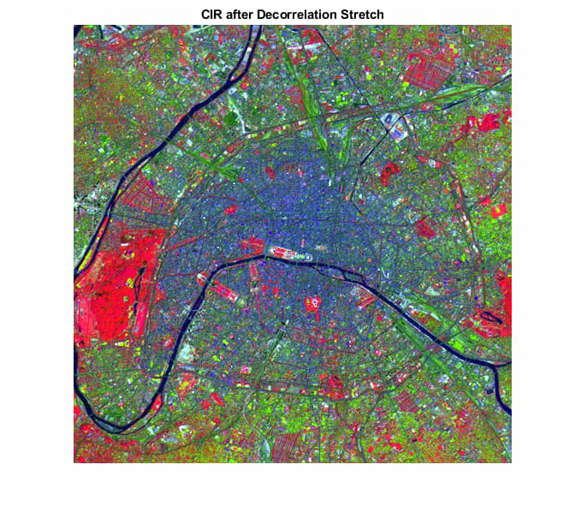

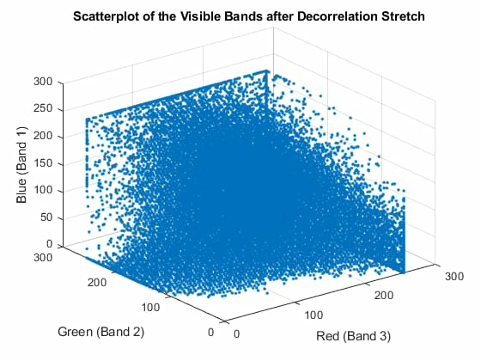

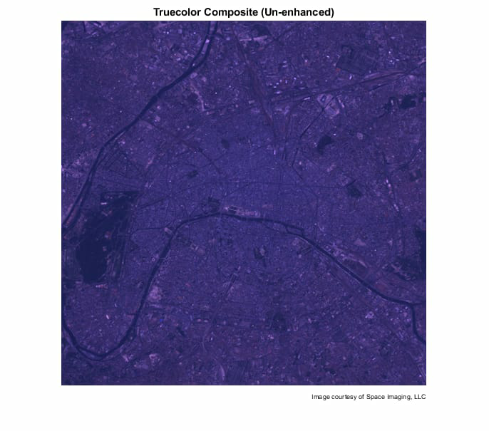

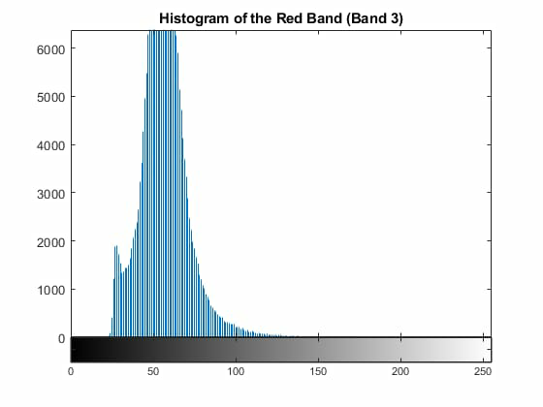

**7 Advantaged and Disadvantages**

The primary advantage to hyperspectral imaging is that, because an entire spectrum is acquired at each point, the operator needs no prior knowledge of the sample, and postprocessing allows all available information from the dataset to be mined. Hyperspectral imaging can also take advantage of the spatial relationships among the different spectra in a neighbourhood, allowing more elaborate spectral-spatial models for a more accurate segmentation and classification of the image.

The primary disadvantages are cost and complexity. Fast computers, sensitive detectors, and large data storage capacities are needed for analyzing hyperspectral data. Significant data storage capacity is necessary since hyperspectral cubes are large, multidimensional datasets, potentially exceeding hundreds of [megabytes](https://en.wikipedia.org/wiki/Megabytes). All of these factors greatly increase the cost of acquiring and processing hyperspectral data. Also, one of the hurdles researchers have had to face is finding ways to program hyperspectral satellites to sort through data on their own and transmit only the most important images, as both transmission and storage of that much data could prove difficult and costly. As a relatively new analytical technique, the full potential of hyperspectral imaging has not yet been realized.

**8.1 Applications**

Hyperspectral remote sensing is used in a wide array of applications. Although originally developed for mining and geology (the ability of hyperspectral imaging to identify various minerals makes it ideal for the mining and oil industries, where it can be used to look for ore and oil),[[9]](https://en.wikipedia.org/wiki/Hyperspectral_imaging#cite_note-Ellis-9)[[18]](https://en.wikipedia.org/wiki/Hyperspectral_imaging#cite_note-Smith-18) it has now spread into fields as widespread as ecology and surveillance, as well as historical manuscript research, such as the imaging of the [Archimedes Palimpsest](https://en.wikipedia.org/wiki/Archimedes_Palimpsest). This technology is continually becoming more available to the public. Organizations such as [NASA](https://en.wikipedia.org/wiki/NASA) and the [USGS](https://en.wikipedia.org/wiki/USGS) have catalogues of various minerals and their spectral signatures, and have posted them online to make them readily available for researchers. On a smaller scale, NIR hyperspectral imaging can be used to rapidly monitor the application of pesticides to individual seeds for quality control of the optimum dose and homogeneous coverage.

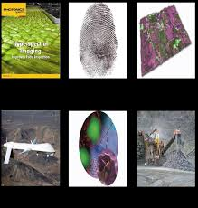

**9. Conclusion and Future Scope**

In this project , we attempted to analyse the Hyper spectral image from the Hyper spectral sensor data, Further development can be performed , It can replace the Radars It can predict the danger without going near the dange

Hyperspectral surveillance is the implementation of hyperspectral scanning technology for [surveillance](https://en.wikipedia.org/wiki/Surveillance) purposes. Hyperspectral imaging is particularly useful in military surveillance because of [countermeasures](https://en.wikipedia.org/wiki/Countermeasure) that military entities now take to avoid airborne surveillance. The idea that drives hyperspectral surveillance is that hyperspectral scanning draws information from such a large portion of the light spectrum that any given object should have a unique [spectral signature](https://en.wikipedia.org/wiki/Spectral_signature) in at least a few of the many bands that are scanned. The [SEALs](https://en.wikipedia.org/wiki/United_States_Navy_SEALs) from [NSWDG](https://en.wikipedia.org/wiki/NSWDG) who killed [Osama bin Laden](https://en.wikipedia.org/wiki/Osama_bin_Laden) in May 2011 used this technology while conducting [the raid](https://en.wikipedia.org/wiki/Death_of_Osama_bin_Laden) (Operation Neptune's Spear) on [Osama bin Laden's compound in Abbottabad](https://en.wikipedia.org/wiki/Osama_bin_Laden%27s_compound_in_Abbottabad), [Pakistan](https://en.wikipedia.org/wiki/Pakistan).Hyperspectral imaging has also shown potential to be used in [facial recognition](https://en.wikipedia.org/wiki/Facial_recognition_system) purposes. Facial recognition algorithms using hyperspectral imaging have been shown to perform better than algorithms using traditional imaging.

Traditionally, commercially available thermal infrared hyperspectral imaging systems have needed [liquid nitrogen](https://en.wikipedia.org/wiki/Liquid_nitrogen) or [helium](https://en.wikipedia.org/wiki/Helium) cooling, which has made them impractical for most surveillance applications. In 2010, [Specim](https://en.wikipedia.org/wiki/Specim) introduced a thermal infrared hyperspectral camera that can be used for outdoor surveillance and [UAV](https://en.wikipedia.org/wiki/UAV) applications without an external light source such as the sun or the moon.

REFERENCE

1. [*spectral Image Analysis*](https://books.google.com/books?id=DqmWQk01mlIC&pg=PR13)*. John Wiley & Sons.*[*ISBN*](https://en.wikipedia.org/wiki/International_Standard_Book_Number)[*978-0-470-01087-7*](https://en.wikipedia.org/wiki/Special:BookSources/978-0-470-01087-7)*.*
2. *Hagen, Nathan; Kudenov, Michael W. (2013).*[*"Review of snapshot spectral imaging technologies"*](https://www.spiedigitallibrary.org/journals/Optical-Engineering/volume-52/issue-9/090901/Review-of-snapshot-spectral-imaging-technologies/10.1117/1.OE.52.9.090901.pdf)*(PDF). Optical Engineering.****52****(9): 090901.*[*Bibcode*](https://en.wikipedia.org/wiki/Bibcode)*:*[*2013OptEn..52i0901H*](https://ui.adsabs.harvard.edu/abs/2013OptEn..52i0901H)*.*[*doi*](https://en.wikipedia.org/wiki/Digital_object_identifier)*:*[*10.1117/1.OE.52.9.090901*](https://doi.org/10.1117%2F1.OE.52.9.090901)*.*
3. [Jump up to:***a***](https://en.wikipedia.org/wiki/Hyperspectral_imaging#cite_ref-lu_4-0) [***b***](https://en.wikipedia.org/wiki/Hyperspectral_imaging#cite_ref-lu_4-1) *Lu, G; Fei, B (January 2014).*[*"Medical Hyperspectral Imaging: a review"*](https://www.ncbi.nlm.nih.gov/pmc/articles/PMC3895860)*.*[*Journal of Biomedical Optics*](https://en.wikipedia.org/wiki/Journal_of_Biomedical_Optics)*.****19****(1): 10901.*[*Bibcode*](https://en.wikipedia.org/wiki/Bibcode)*:*[*2014JBO....19a0901L*](https://ui.adsabs.harvard.edu/abs/2014JBO....19a0901L)*.*[*doi*](https://en.wikipedia.org/wiki/Digital_object_identifier)*:*[*10.1117/1.JBO.19.1.010901*](https://doi.org/10.1117%2F1.JBO.19.1.010901)*.*[*PMC*](https://en.wikipedia.org/wiki/PubMed_Central)[*3895860*](https://www.ncbi.nlm.nih.gov/pmc/articles/PMC3895860)*.*[*PMID*](https://en.wikipedia.org/wiki/PubMed_Identifier)[*24441941*](https://www.ncbi.nlm.nih.gov/pubmed/24441941)*.*
4. [Jump up to:***a***](https://en.wikipedia.org/wiki/Hyperspectral_imaging#cite_ref-microscopyu.com_5-0) [***b***](https://en.wikipedia.org/wiki/Hyperspectral_imaging#cite_ref-microscopyu.com_5-1) [*"Nikon MicroscopyU – Confocal Microscopy – Spectral Imaging"*](http://www.microscopyu.com/articles/confocal/spectralimaging.html)*.*
5. [Jump up to:***a***](https://en.wikipedia.org/wiki/Hyperspectral_imaging#cite_ref-autogenerated2_6-0) [***b***](https://en.wikipedia.org/wiki/Hyperspectral_imaging#cite_ref-autogenerated2_6-1) [***c***](https://en.wikipedia.org/wiki/Hyperspectral_imaging#cite_ref-autogenerated2_6-2) [***d***](https://en.wikipedia.org/wiki/Hyperspectral_imaging#cite_ref-autogenerated2_6-3) <http://www.bodkindesign.com/wp-content/uploads/2012/09/Hyperspectral-1011.pdf>
6. [Jump up to:***a***](https://en.wikipedia.org/wiki/Hyperspectral_imaging#cite_ref-opticsinfobase.org_7-0) [***b***](https://en.wikipedia.org/wiki/Hyperspectral_imaging#cite_ref-opticsinfobase.org_7-1) [***c***](https://en.wikipedia.org/wiki/Hyperspectral_imaging#cite_ref-opticsinfobase.org_7-2) [*"OSA – Basic slit spectroscope reveals three-dimensional scenes through diagonal slices of hyperspectral cubes"*](http://www.opticsinfobase.org/ao/abstract.cfm?uri=ao-53-20-4594)*.*
7. [Jump up to:***a***](https://en.wikipedia.org/wiki/Hyperspectral_imaging#cite_ref-Schurmer_8-0) [***b***](https://en.wikipedia.org/wiki/Hyperspectral_imaging#cite_ref-Schurmer_8-1) [***c***](https://en.wikipedia.org/wiki/Hyperspectral_imaging#cite_ref-Schurmer_8-2) Schurmer, J.H., (Dec 2003), Air Force Research Laboratories Technology Horizons
8. [Jump up to:***a***](https://en.wikipedia.org/wiki/Hyperspectral_imaging#cite_ref-Ellis_9-0) [***b***](https://en.wikipedia.org/wiki/Hyperspectral_imaging#cite_ref-Ellis_9-1) Ellis, J., (Jan 2001) [*Searching for oil seeps and oil-impacted soil with hyperspectral imagery*](http://www.eomonline.com/Common/currentissues/Jan01/ellis.htm)[*Archived*](https://web.archive.org/web/20080305014626/http:/www.eomonline.com/Common/currentissues/Jan01/ellis.htm)*2008-03-05 at the*[*Wayback Machine*](https://en.wikipedia.org/wiki/Wayback_Machine)*,* Earth Observation Magazine.
9. [Jump up to:***a***](https://en.wikipedia.org/wiki/Hyperspectral_imaging#cite_ref-biomedicaloptics.spiedigitallibrary.org_10-0) [***b***](https://en.wikipedia.org/wiki/Hyperspectral_imaging#cite_ref-biomedicaloptics.spiedigitallibrary.org_10-1) *Lu, Guolan; Fei, Baowei (2014).*[*"SPIE – Journal of Biomedical Optics – Medical hyperspectral imaging: a review"*](https://www.ncbi.nlm.nih.gov/pmc/articles/PMC3895860)*. Journal of Biomedical Optics.****19****(1): 010901.*[*Bibcode*](https://en.wikipedia.org/wiki/Bibcode)*:*[*2014JBO....19a0901L*](https://ui.adsabs.harvard.edu/abs/2014JBO....19a0901L)*.*[*doi*](https://en.wikipedia.org/wiki/Digital_object_identifier)*:*[*10.1117/1.JBO.19.1.010901*](https://doi.org/10.1117%2F1.JBO.19.1.010901)*.*[*PMC*](https://en.wikipedia.org/wiki/PubMed_Central)[*3895860*](https://www.ncbi.nlm.nih.gov/pmc/articles/PMC3895860)*.*[*PMID*](https://en.wikipedia.org/wiki/PubMed_Identifier)[*24441941*](https://www.ncbi.nlm.nih.gov/pubmed/24441941)*.*